Software Requirement Specification For

BookTickZ

# Group Details:

R Anitha Sai Saranya - AM.EN.U4CSE15148

R O Mounica - AM.EN.U4CSE15150

Sarath Chandrika K - AM.EN.U4CSE15154

Usha M - AM.EN.U4CSE15161

Y Himavarshini - AM.EN.U4CSE15167

# Project Summary:

This project involves in developing an online movie ticket booking portal. It provides easy access to end users minimising most of their difficulties.

## Project Overview:

A User friendly website, BookTickZ provides a convenient and faster way to end users to book film tickets.

## Project Scope:

### In Scope:

* User Authentication
* Admin Authentication
* Online payment gateway
* E - ticket booking

### Out of Scope :

* Theatres and the places included in the database are limited

## Development Process:

We follow the agile model of software development. The product will be developed in following two sprints.

The Product Backlog are the following:

|  |  |
| --- | --- |
| **Module** | **Purpose** |
| Login Management | Manage the user access |
| Movie Management | Manage movie bookings |
| Transaction Management | Manage payments |
| Ticket Management | Manage shows in the theatres |

### First Sprint:

|  |  |  |
| --- | --- | --- |
| **Module Name** | **Use Case** | **Description of Use case** |
| Login management | Register | New user registration with profile details |
| Login | Registered user login |
| Update Profile | Can change name and password |
| Forgot Password | Can help users and administers in setting a new password if they wish to change |
| Movie management | Add movie | Admin can add movies to a theatre |
| Delete movie | Admin can delete movies |
| Choose Movie | Can select movie to which user wishes to book tickets from the list of available movies |
| Select venue and show time | Can select theatre and show time based on users comfort |

### Second Sprint:

|  |  |  |
| --- | --- | --- |
| **Module Name** | **Use Case** | **Description of Use case** |
| Ticket Management | Seat Layout | Availability of tickets |
| Select Seat | Can select seats among the available seats |
| Cancel ticket and refund | Can cancel ticket thereby refunding the amount to user |
| Transaction Management | Payment | Managing Transaction and get confirmation message |
| Managing Security | Sending and Verifying OTP |

# Team Organization:

|  |  |
| --- | --- |
| **Name** | **Role** |
| Jayasree Narayan | Product Owner |
| Usha Mundra | Supervisor, Documentation |
| Sarath Chandrika K | Developer |
| R Mounica | Developer |
| Y Hima Varshini | Tester |
| Rayankula Anitha Sai Saranya | Scrum Master, Tester |

# Specific Requirements:

## Functional Requirements:

### Use case Diagram:

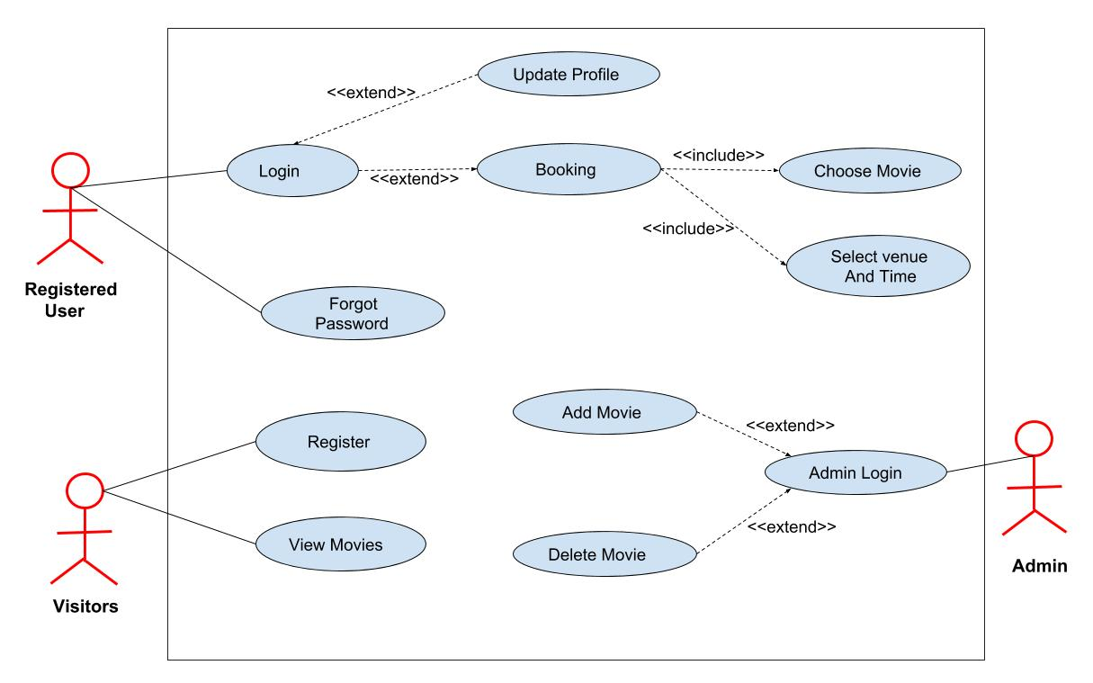

### Class Diagram:

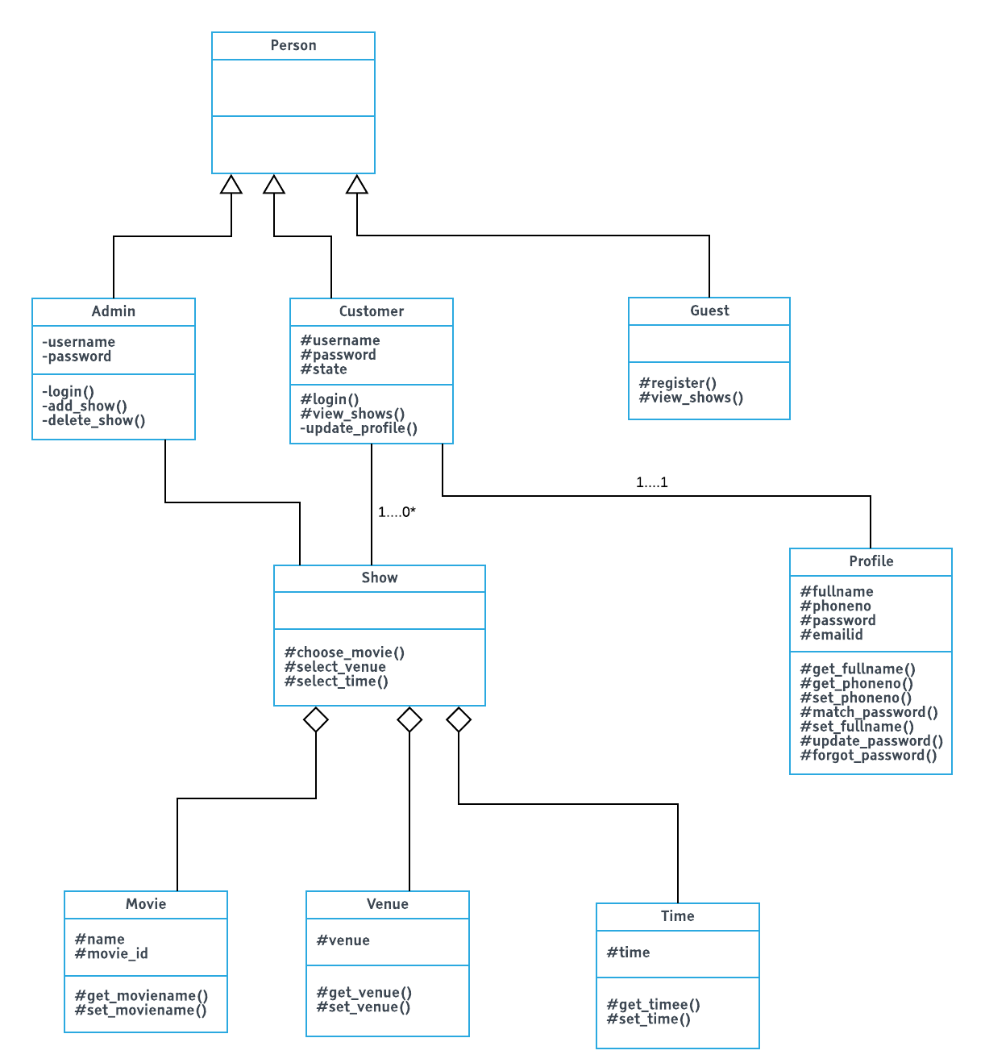

### Use case Scenarios and Sample Screens:

|  |  |
| --- | --- |
| Use-Case | Register |
| Primary Actor | Administrator, End User |
| Goal in context | Creating a profile |
| Pre-conditions | email-id, phone number |
| Scenario | 1. Prompts user to enter name, username, phone number, email-id and password. 2. System creates an account. 3. Dashboard is displayed with profile details. |
| Exceptions | 1. Arise when same usernames are requested by different users. 2. Registration failure with invalid email-id. |
| Priority | 1 |
| When available | First Sprint |

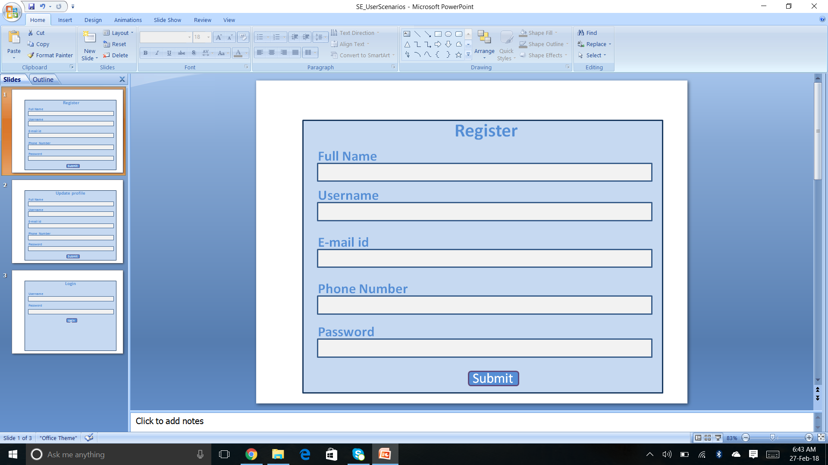

|  |  |
| --- | --- |
| Use-Case | Login |
| Primary Actor | Administrator, End Users |
| Goal in context | Accessing profile |
| Pre-conditions | email-id, username, password |
| Scenario | 1. Start the application. User prompted for username, password. 2. System access an account from database. 3. Dashboard is displayed with profile details. |
| Exceptions | Login failure with wrong username or password. |
| Priority | 2 |
| When available | First Sprint |

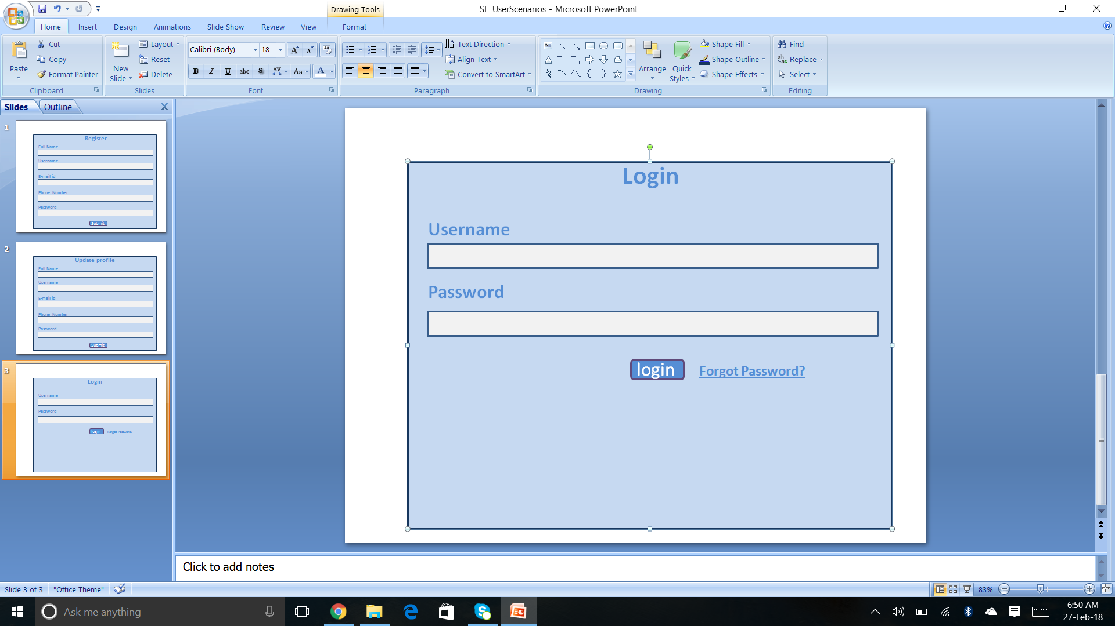

|  |  |
| --- | --- |
| Use-Case | Update Profile |
| Primary Actor | End Users |
| Goal in context | Accessing profile and changing basic details |
| Pre-conditions | email-id, username, password |
| Scenario | 1. Prompts user to enter email-id and password. 2. After Authentication provides access to profile. 3. Profile containing user details gets displayed. 4. Provides update options to phone number, password, personal details. |
| Exceptions | Giving same password as of previous password after requesting for update password |
| Priority | 3 |
| When available | First Sprint |

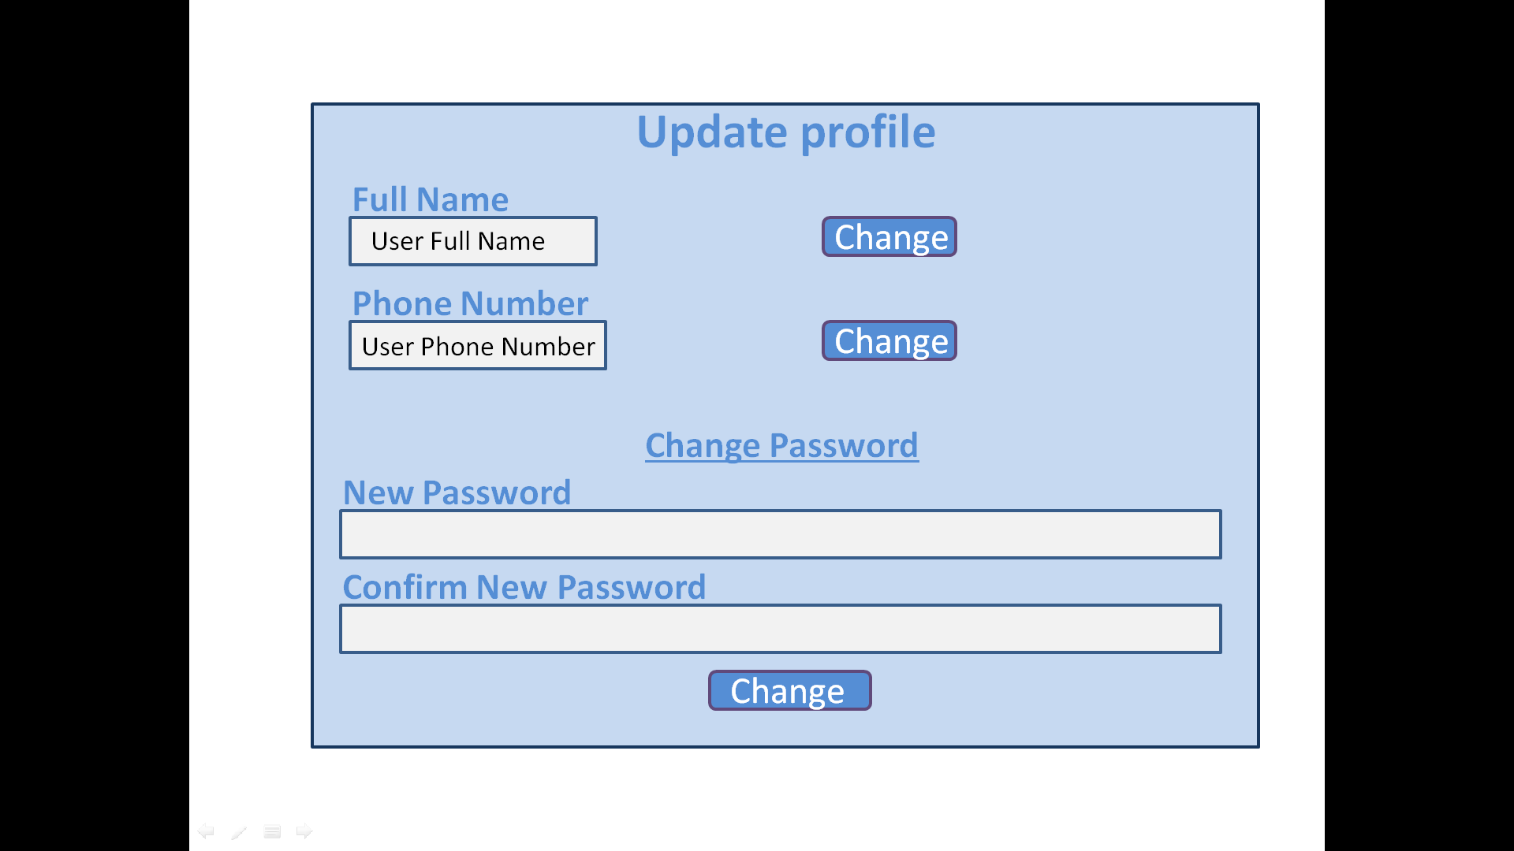

|  |  |
| --- | --- |
| Use-Case | Forgot Password |
| Primary Actor | Administrator, End User |
| Goal in context | Creating a new password to access existing account |
| Pre-conditions | username, email-id |
| Trigger |  |
| Scenario | 1. Prompts user to enter username 2. System asks for email-id for further communications 3. Security alert goes to corresponding mail for the required changes. |
| Exceptions | Arise when corresponding email-ids are not given for the username |
| Priority | 4 |
| When available | First Sprint |

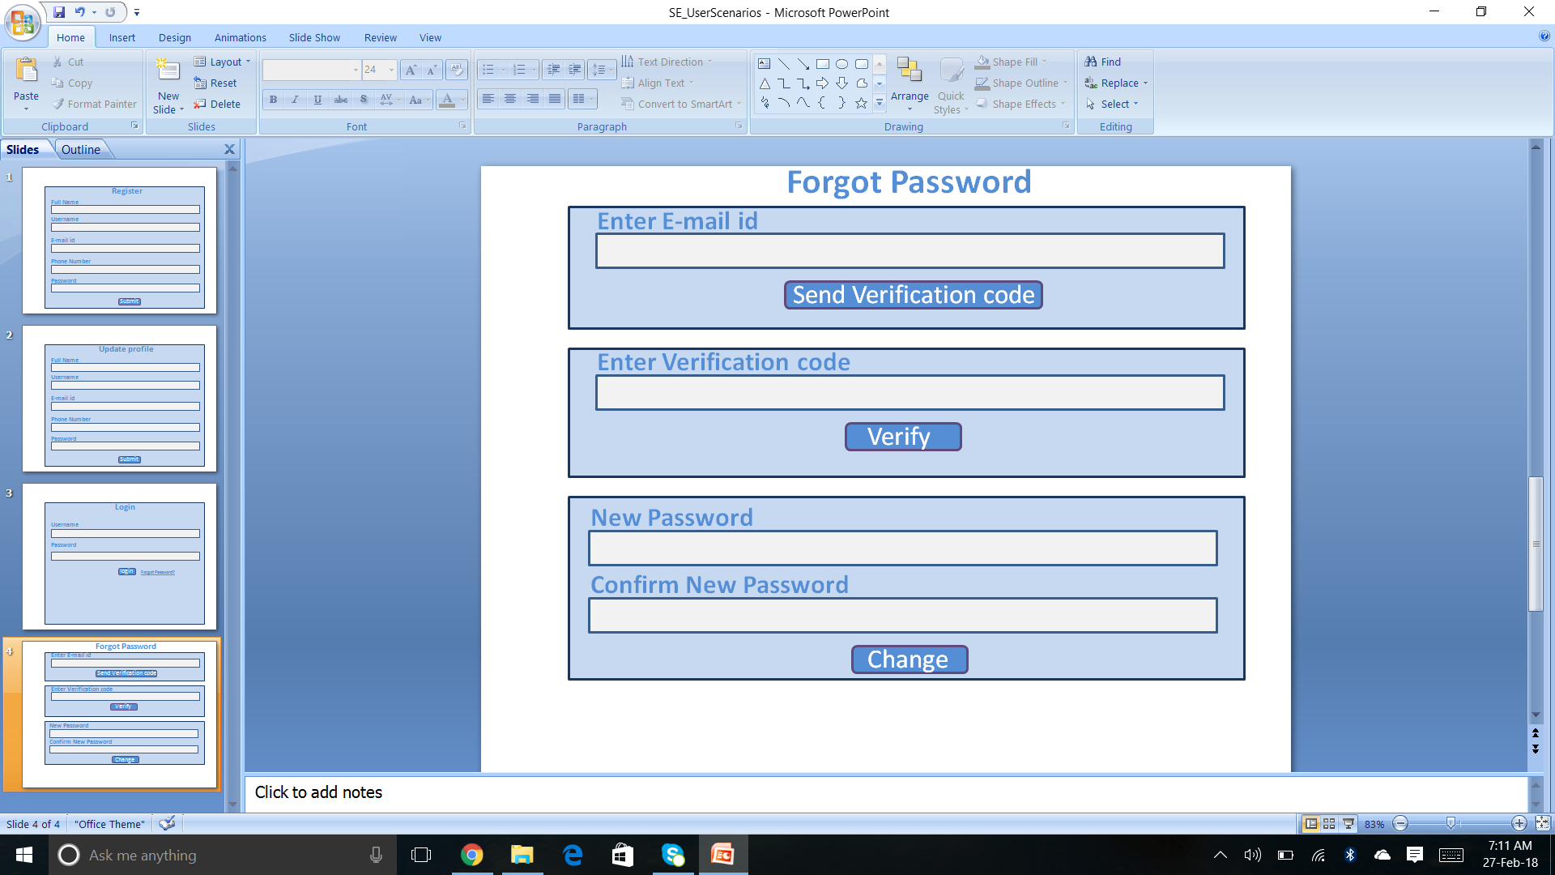

|  |  |
| --- | --- |
| Use-Case | Add movie |
| Primary Actor | Administrator |
| Goal in context | Adding a new movie to the database |
| Pre-conditions | email-id, password, details of movie |
| Trigger |  |
| Scenario | 1. After successful login displays a screen for adding movies. 2. Details of movie can be added. |
| Exceptions | Two movies cannot be added for the same show time and venue |
| Priority | 1 |
| When available | First Sprint |

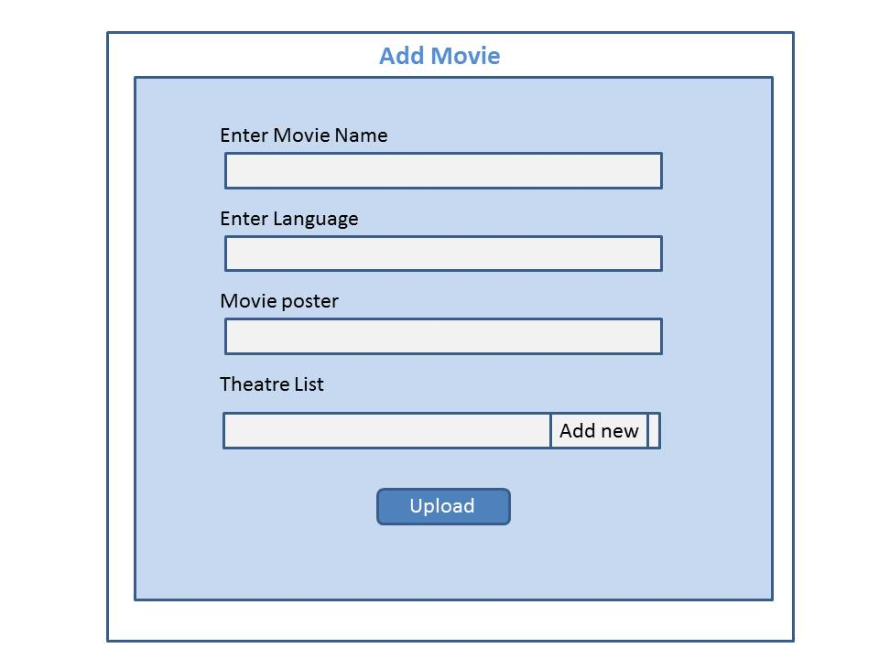

|  |  |
| --- | --- |
| Use-Case | Choose movie |
| Primary Actor | Enduser |
| Goal in context | Can choose movie from the list of available movies |
| Pre-conditions | email-id, password, details of movie |
| Scenario | 1. After successful login displays a screen for adding movies. 2. Details of movie can be added. |
| Exceptions | Two movies cannot be added for the same show time and venue |
| Priority | 1 |
| When available | First Sprint |

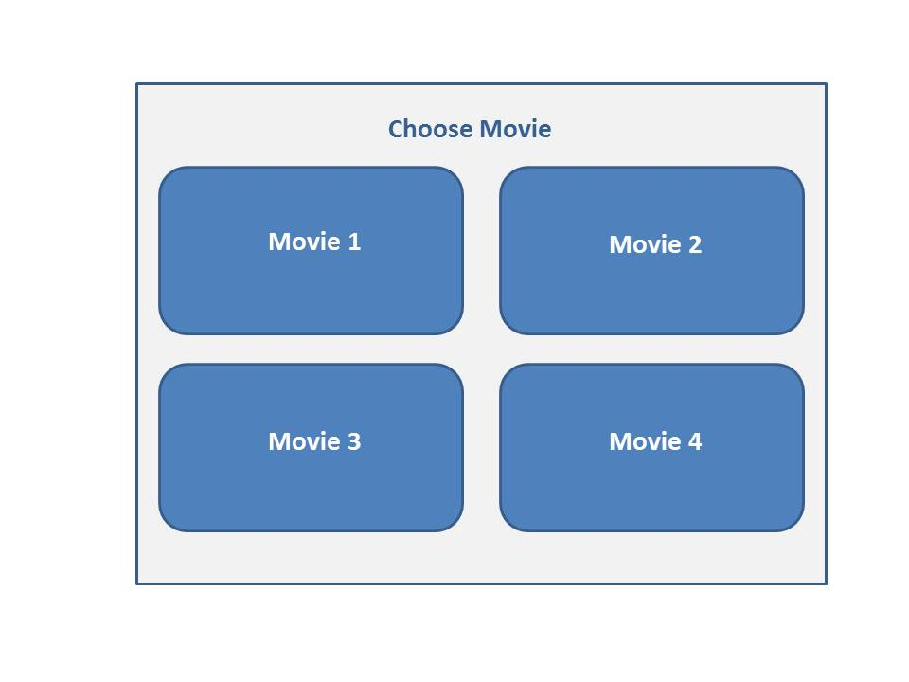

|  |  |
| --- | --- |
| Use-Case | Delete movie |
| Primary Actor | Administrator |
| Goal in context | Deleting a movie from the database |
| Pre-conditions | email-id, password |
| Scenario | After successful login displays a screen for deleting existing movies from database. |
| Exceptions | Cannot delete if movie is not present in Database. |
| Priority | 2 |
| When available | First Sprint |

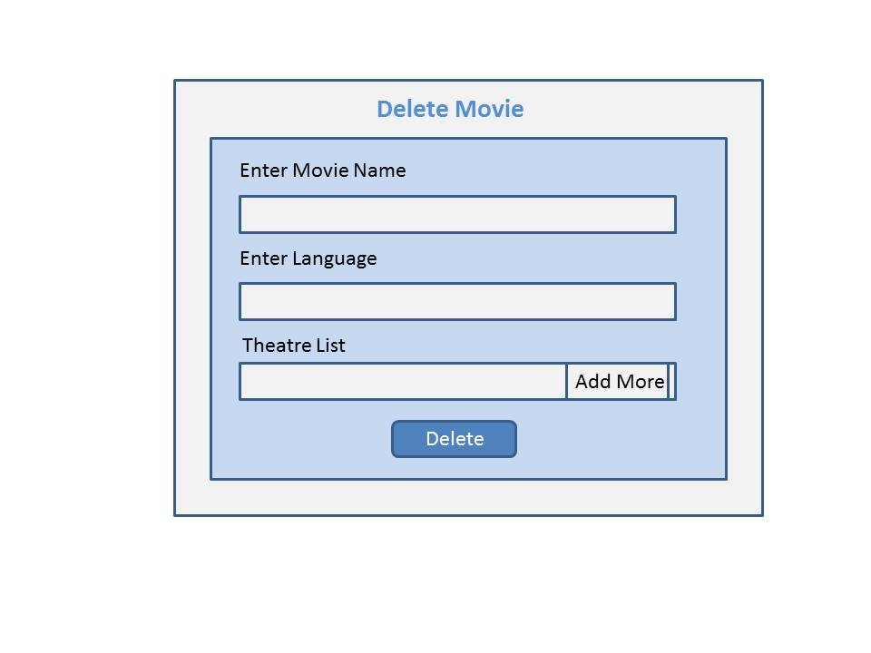

|  |  |
| --- | --- |
| Use-Case | Choose venue and show time |
| Primary Actor | Enduser |
| Goal in context | Can choose movie venue and show time from the list of availabilities |
| Pre-conditions | email-id, password |
| Scenario | 1. After successful login displays a screen showing lists of theatres and show timings where user can select according to his interest. 2. Prompts to a screen with screen layout where he can select seats of his choice. |
| Exceptions | If entered theatre is not present in the list. |
| Priority | 2 |
| When available | First Sprint |

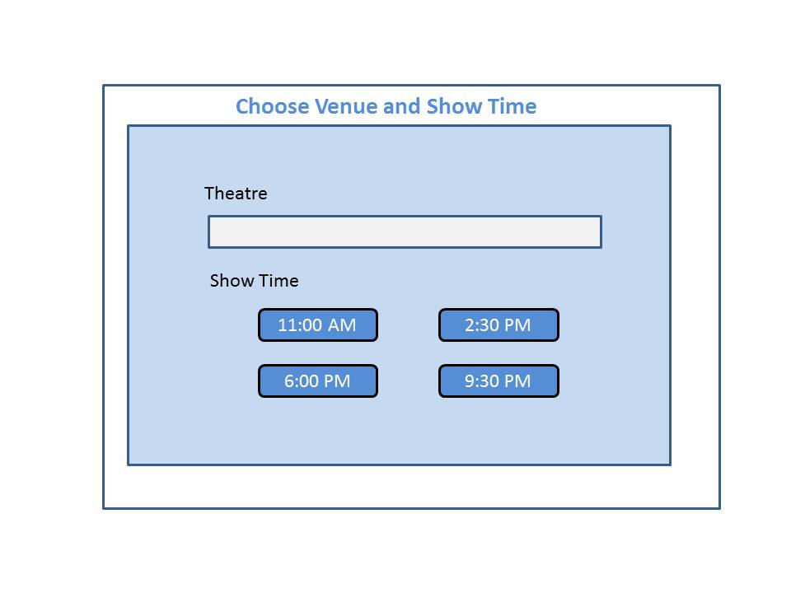

**………………………………….End of First Sprint…………………………………**